24BYB1117 Rakshit Rameshbabu
DBS LAB Assignment
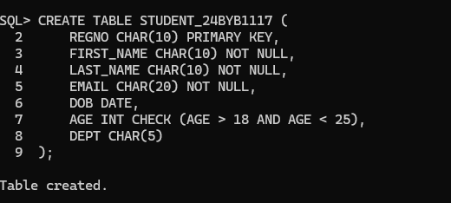
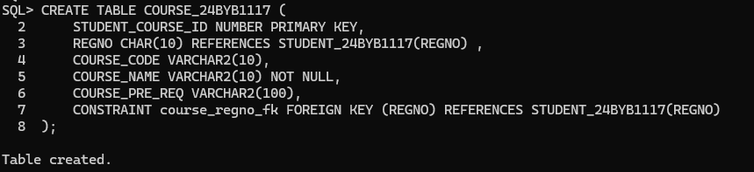
DML:
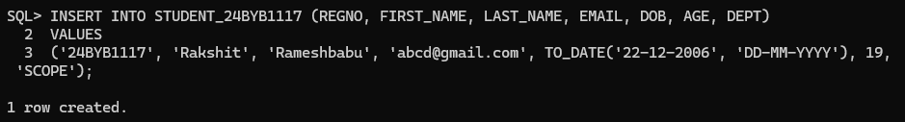
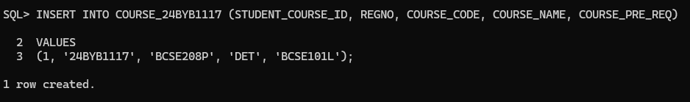
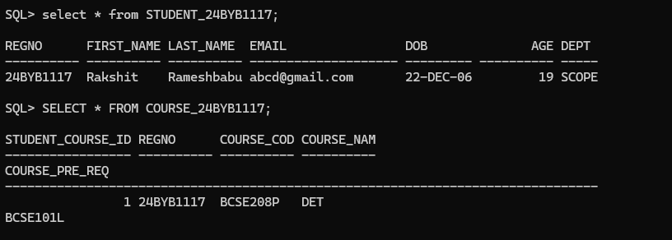
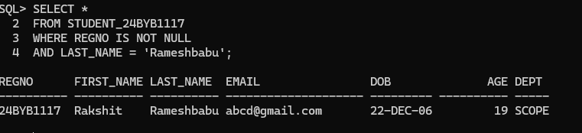
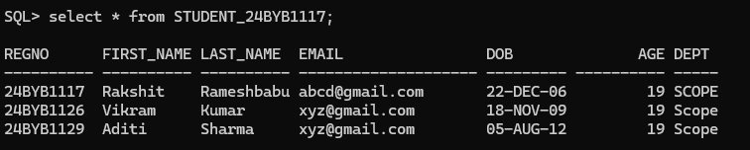
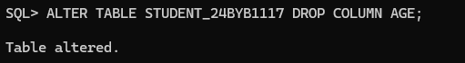
SQL> DROP TABLE STUDENT_24BYB1117;
DROP TABLE STUDENT_24BYB1117
*
ERROR at line 1:
ORA-02449: unique/primary keys in table referenced by foreign keys

